Ciarán Maher

23rd-September-2015 Assignment A
Table of Contents
Task A | Task B | Task C | Task D | Task E
Task A.1 | Task B.1 | Task C.1 | Task D.1 | Task E.1
Task A.2 |  | Task C.2 | Task D.2 | Task E.2
Task A.3 |  | Task C.3
Task A.4
Task A.5
Task A.6
Task A.7

Ctrl + Left-click to follow hyperlinks.

Task A

Task A.1
Explain, in approximately 200 words, the reasons why customer service should be prompt and professional. Include three effects on the customer if it is not and three effects on the support organisation if it is not.
It is important that customer service should be prompt and professional as it provides multiple opportunities to improve both customer and employee satisfaction. When customers feel their concerns and issues are important to the support organisation, they are more likely to remain loyal to the brand; and encourage their friends and colleagues to use and share your products. When customers feel their concerns and issues are not important to the support organisation then they are more likely to be frustrated and resentful of bugs, corporate policies and outages.
Employee satisfaction is also an important aspect that can be affected by poor customer services. Employee satisfaction is often a reflection of customer satisfaction and can also have a negative feedback loop whereby employee frustrations are taken out on the customer and a self-perpetuating loop is created.
These types of issues can be avoided by ensuring the employee’s receive sufficient training and coaching to quickly identify and address customer problems. This results in a much better environment for your business to thrive.
To summarise and identify the key points of this essay:

3 effects on customers if customer service is not prompt and professional are:
- Failure to be able to use the product effectively
- Loss of man hours/money
- Annoyance

3 effects on the support organisation if customer service is not prompt and professional are:
- Loss of revenue
- Reputation damage
- Toxic work-place

Task A.2
Describe three different ways of providing technical support, including at least one remote method (other than technical helpdesk).

Three ways of providing technical support are phone support, email support and remote desktop management.

Phone support involves trained and knowledgeable customer support representatives (CSRs) taking calls from customers to troubleshoot their technical support issues and queries.

Email support allows CSRs to provide simple, but detailed answers to customer queries and also takes the pressure off the organisation to have instant solutions available to customers.

Remote desktop management allows CSRs the option of logging into the customer’s computer and directly applying solutions to the customer’s hardware. Windows features this service directly, but other software suites can be employed to adapt to different needs. Examples of these software options are LogMeIn and GoToAssist.

Task A.3
Obtain a software update or patch as directed by your assessor. Save it onto a storage medium as instructed by your assessor. Rename the patch file to reflect what it is and what its use is.

http://download.adobe.com/pub/adobe/photoshop/win/13.x/Photoshop_CS6_13_0_1_2_upd.zip
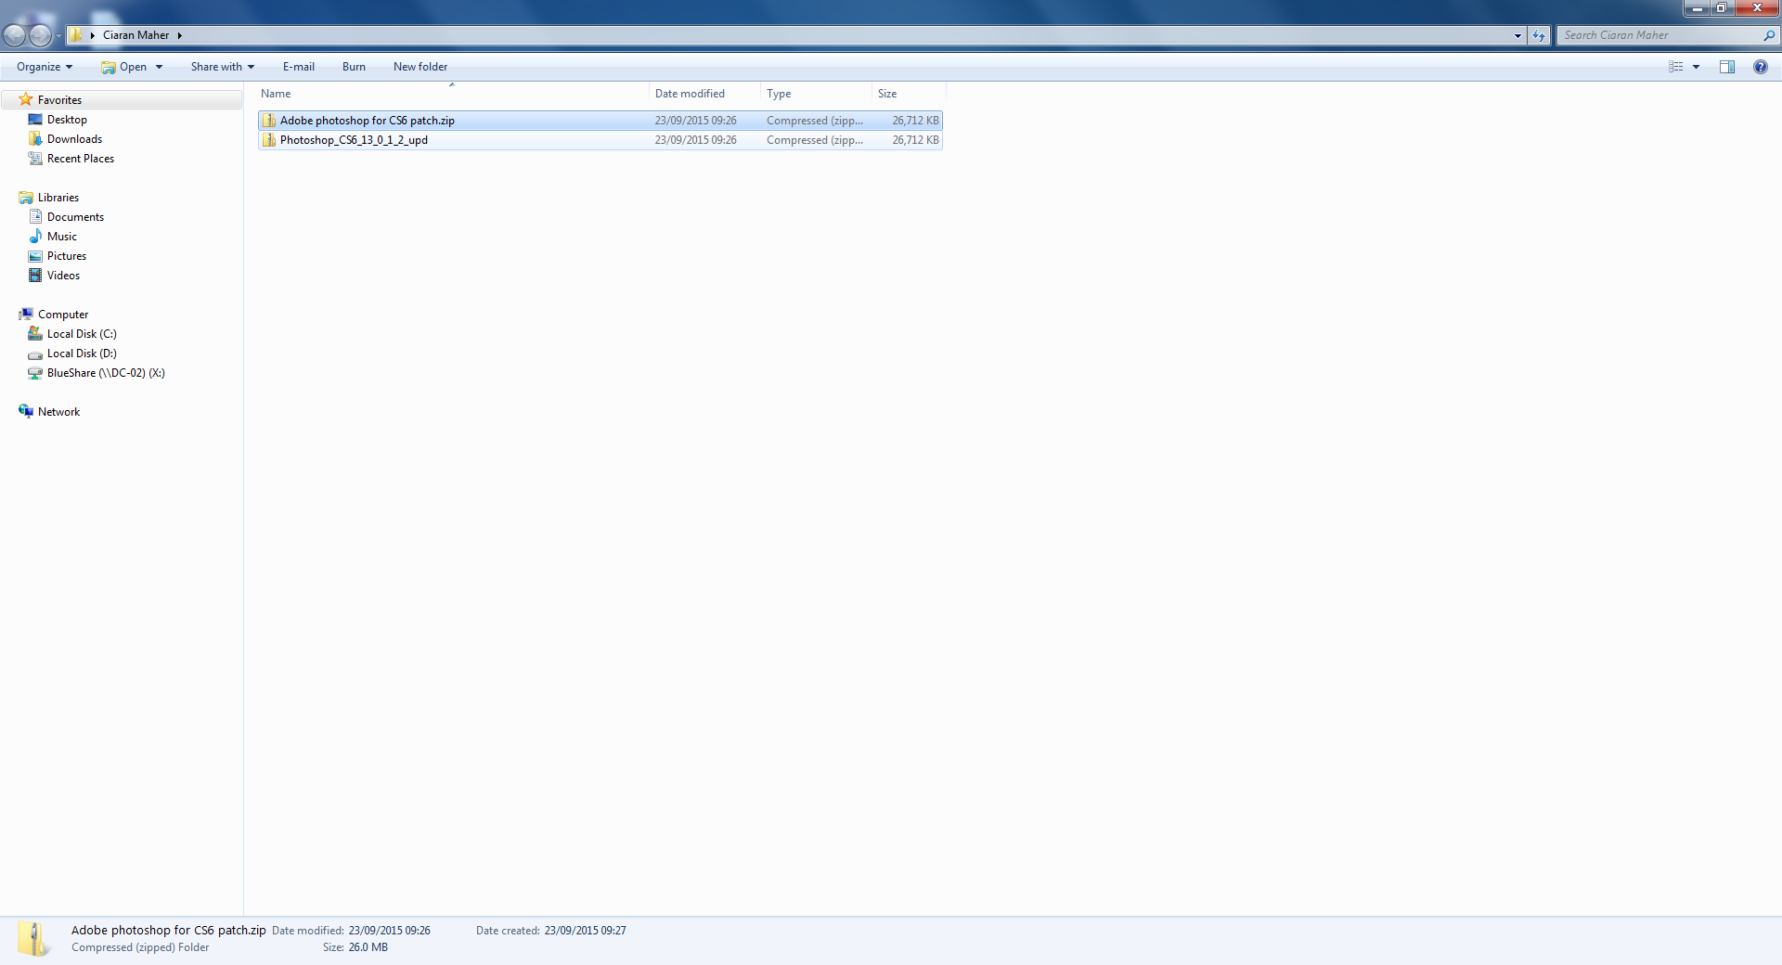

Task A.4
Locate a hardware driver for a device as specified by your Assessor. Save it to disk.

http://belgium.oki.com/Includes/Pages/FileDownload.aspx?id=tcm:125-142578
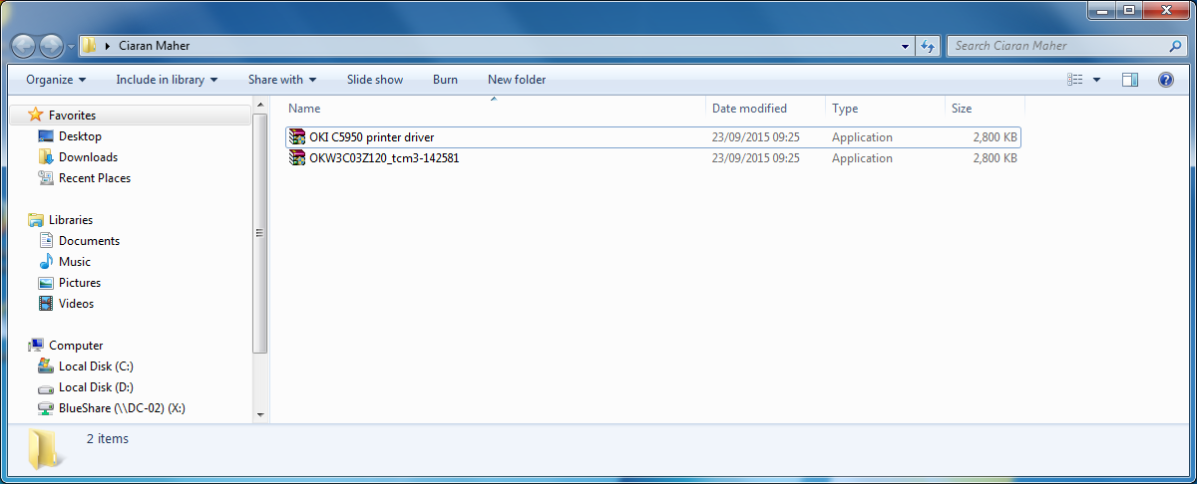

Task A.5
Download an operator manual as directed by your Assessor. Save the document to a local drive or network location and check that you have the correct software to view the contents. Produce a screen print as evidence of the download.

http://www2.unine.ch/files/content/sites/serv_sitel/files/shared/documents/copieurs/iRADV_C5255_USERS_multi_R.pdf
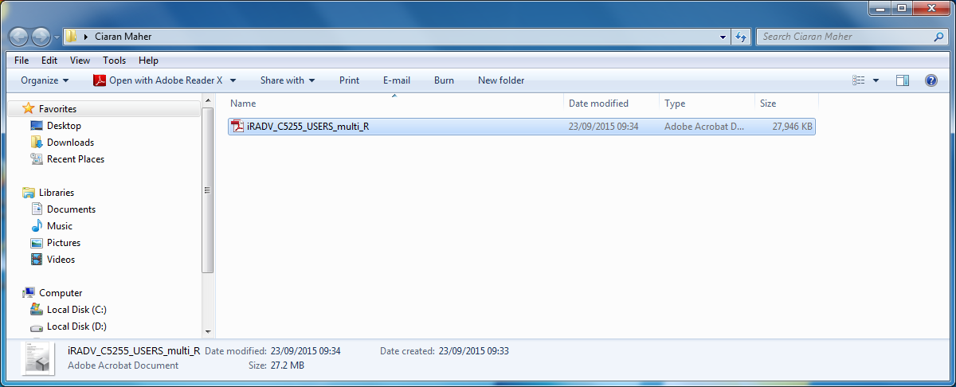
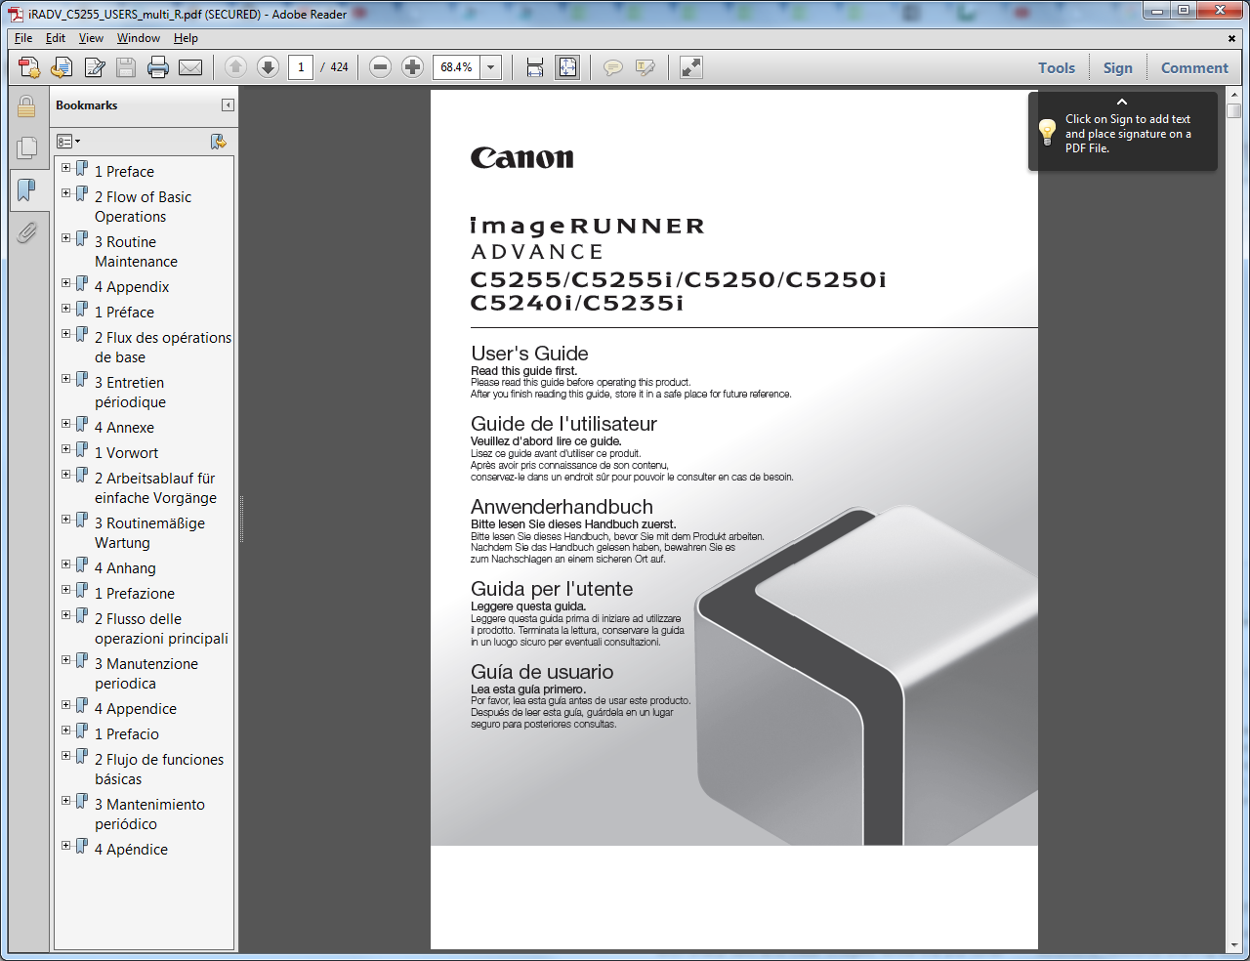

Task A.6
On the ICT contact sheet provided, prepare a list of five telephone numbers for the customer support centres of major ICT support companies. Include one printer manufacturer, one software supplier, one ICT hardware supplier, one hardware maintenance company and one electronic component supplier.

ICT contact sheet for 7540-030 Assignment A
Candidate name: Ciarán Maher
Date: 23rd-September-2015

City & Guilds Enrolment number:

Company | Type of Company | Telephone Number
imageCLASS Printers | Printer manufacturer | 1-800-OK-CANON  1-800-652-2666
Gamestop | Software supplier | (01) 872 5488
Maplin | ICT hardware supplier | (01) 878 2388
Tech Assist.ie | Hardware maintenance company | 01 8237394
Komplett.ie | Electronic component supplier | 01 4433 150

Task A.7
You have been asked to investigate a technical problem. This fault has already been referred to your senior support specialist and you have to collect full information for them to evaluate.
Design a template that could be used to collect the information. The template should be divided into sections and headings to show that you have considered all types of relevant information. It must provide the support specialist with enough information to make a remote diagnosis. Assume that the specialist will have no other information about the problem except that contained in the template.

Customer Details
Account Number | Name | Department |  | Date |  | Time

Issue
Type of problem | Hardware |  |  | Software

Frequency of problem

Symptoms of problem

Environment/Other Users

Hardware Details

Serial Number

Processor/Ram

Accessories

Additional Devices

Any recent changes

History of the Computer

Software Details

What Operating System are you using?

What version of the software are you using?

Anti-virus/Firewall

Installed anything recently

Troubleshooting

Action taken

Time of Resolution

Ticket Closed

Priority

Task B – Assess customer feedback

Task B.1
Support companies frequently survey their customers to establish their level of satisfaction. A popular method is a telephone survey. There is a particular problem with the service being delivered by technical couriers in your company. Their role is to provide basic installation services for the replacement of peripherals. Write ten questions that could be asked in a telephone survey of your customers. The survey will be undertaken by non-technical staff and should cover the complete life-cycle of the request for service. The questions should collect the maximum information and be suitable for entering into an analysis sheet. You should use two or more styles of answer eg graded, yes/no. You do not need to include the following in your questions: customer name, customer address, customer contact name and telephone number, call reference number.

- How long were you waiting before speaking with our customer service representative?
  - Not long at all
  - Slightly long
  - Moderately long
  - Quite long
  - Extremely long
- How well did you feel our customer service representative understood your issue?
  - Extremely well
  - Quite well
  - Moderately well
  - Slightly well
  - Not well at all
- How efficient would you say that our customer service representative solved your issue or answered your question?
  - Extremely efficiently
  - Very efficiently
  - Moderately efficiently
  - Slightly efficiently
  - Not efficiently at all
- How knowledgeable did our customer service representative seem to you?
  - Extremely knowledgeable
  - Quite knowledgeable
  - Moderately knowledgeable
  - Slightly knowledgeable
  - Not knowledgeable at all
- How clear was the information that our customer service representative provided you?
  - Extremely clear
  - Quite clear
  - Moderately clear
  - Slightly clear
  - Not clear at all
- How many of your questions/problems did the customer service representative at our company resolve?
  - All of them
  - Most of them
  - About half of them
  - Some of them
  - None of them
- Overall, are you satisfied with the customer service you received?
  - Extremely satisfied
  - Quite satisfied
  - Moderately satisfied
  - Slightly satisfied
  - Not satisfied at all
- Would you recommend our company to a friend or colleague?
Yes |  |  |  |  | No
- On a scale of 1-10, how positive would your recommendation about our company be?
(1 being least positive, 10 being most positive)
1 | 2 | 3 | 4 | 5 | 6 | 7 | 8 | 9 | 10
- Are you still a customer with our organisation?
Yes |  |  |  |  | No

Task C – Interpret trends

Task C.1
Briefly describe data filtering.
Data filtering is the term given to the manipulating of existing raw data into useful information to examine particular trends or patterns. These patterns may be positive or negative but in any case are almost always useful to an organisation attempt to capitalise on existing trends to increase market growth.
In addition, data filtering can be useful for discovering negative trends in order to create effective responsive strategies.
An example of data filtering would be in the case of a stolen credit card, examining the transactions that took place between the time the card was stolen and the time it as reported stolen, can effectively communicate any potential malicious withdrawals from the owner’s account.
In a customer service context, data filter allows the organisation to identify key areas where productivity can be improved, by creating specifically tailored response templates to ensure low average response times.
Finally, data filtering may also be employed to identify when there are the most concurrent users availing of the organisations’ infrastructure. This can easily highlight needs for improving hardware needs, or increased need for additional employees available at any given time.

Task C.2
Look at the trend symptoms on the Trend Analysis Sheet provided by your assessor. In the spaces provided on the sheet, list two possible causes and two items of preventative action, for each trend.
Trend analysis sheet
Trend symptoms
During the last three weeks, several calls have been received from a customer, requesting support for their laser printers. The problem statements have indicated that the paper is not being fed correctly from the paper tray. There has been more than one printer with the same problem, and the fitting of new feed rollers has improved, but not always rectified the fault. There have been no previous calls from this customer for this type of problem. There are no other customers reporting this type of problem.
Possible cause or causes
- User error
- Soiled paper feed
Preventative action
1: Educate user on how to correctly load paper into the paper tray and how to identify when paper has not been loaded properly.
2: Submit a maintenance request, and send a printer technician to examine and if necessary, clean and maintain the problem printer(s).

Trend symptoms
Four customers have requested support. The symptoms indicate hardware failures and relate to ICT systems and peripherals. In all cases, the failure has resulted in a complete failure of the unit, either with loss of power or loss of communication. The customers are all located within a 1-mile radius and the faults were reported within a period of one hour.
Possible cause or causes
- Local Internet Service Provider (ISP) issue
- Local power issue
Preventative action
1: Gather information on the affected users’ Internet Service Provider (ISP), if there is a common correlation, then advise users it is a known issue and we will keep them updated. Investigate further at a later date.
2: Gather information on the affected users’ power supplier, if there is a common correlation, then advise users it is a known issue and we will keep them updated. Investigate further at a later date.

Trend symptoms
From an analysis of customer calls, the following statistics have been obtained:
Hardware calls – 32%
Software calls – 15%
Application support – 31%
Other – 22%
Fixed on site – 22%
Fixed off site – 78%
Fixed by first phone call – 54%

Analysis has indicated that there is a “top ten” of repeat requests. The top three are
- How to recover lost files.
- Internet connection problems.
- Failure to connect to a network.
Possible cause or causes
- Unclear technical documentation
Preventative action
1: Create additional user technical documentation to address common queries such as these, a simple FAQ can provide boundless information to allow users to rectify these types of issues themselves.
2: Setting up a forum to allow users to discuss their technical frustrations can allow a good opportunity for users to vent their frustrations, but in a constructive medium where trends can be monitored in real-time, as well as allowing other users to provide simple first level of support with little negative consequences to the organisation.

Task C.3
Briefly describe trends that may occur in support requests.
There are various types of trends which may occur in support requests, these trends usually take the form of either ‘user related’, ‘software related’, ‘hardware related’ or ‘other’.

User related
User related trends traditionally tend to be problems which come about due to user error, or lack of information given to the user. These types of trends can be the most difficult to deal with as it usually involves frustrated or otherwise disenfranchised users.
These types of issue can be avoided by producing high-quality, intuitive and concise technical documentation in the form of FAQs, user manuals and a common issues section in the organisation’s helpdesk.

Software related
Software related trends are most commonly caused by unintended interactions between organisation software and other 3rd party programs such as ‘Virus scanners’, ‘back-up programs’ and even ‘Operating Systems’.
These types of problems can be best averted by thorough testing with all relevant software to ensure compatibility with existing software.

Hardware related
Hardware related trends often occur due to faults with the hardware itself, or with the users’ hardware not meeting minimum specifications for the required software.
These types of trends can be circumvented by ensuring detailed information is made available and updated regularly, to advise players of these requirements. Tier 1/First line of support will generally identify hardware faults quite quickly also.

Other
Other trends can occur that do not fall into any of these types of categories. These types of issues typically cannot be pre-classified but examples of the types of problems that might occur in this category are external sources of problems such as ISP or power outages in a particular area.

Task D – Provide remote technical support

Task D.1
Remote support organisations often use specialist teams to respond to customer requests for service. Design a simple flow chart, with question points, starting from the customer making their initial call and leading to a response by a specialist. The chart should be capable of being used to recommend the layout of an automatic telephone routing system in a call centre handling:
• hardware support
• software support
• installations
• upgrades.

The call centre supports a wide range of IT equipment, and there should be provision for a customer enquiry that does not fit in to the normal call flow. Check that a customer can ask for progress about an existing call without logging a new call.
Incoming Call
Transfer
New Support Request
Existing Support Request
Other
Other
Resolve Request
Hardware Support
Software Support
Installation
Upgrades
Issue Resolved?
No
Yes
Call-back
Ticket Closed
Escalate
Ticket left open (Undesirable)

Task D.2
You have listened to a customer call to the customer call centre and are concerned at the lack of structure to the diagnosis process. The customer has an ICT workstation that will not operate. Use the diagnosis script sheet provided to write a short script that a call centre diagnosis engineer could use for this type of fault. Include suitable tests that could be carried out remotely. The script will help the diagnosis engineer repeat the diagnosis steps in a logical order for each occasion that this type of fault is reported.

Customer Name:  Joey Blogs | Customer Address:  Blogs Estate, Some Place Nice, Near the Beach.  Post Code:  90210  Telephone Number:  - 192 834756
Please could you give me the following information about your ICT system?
Question: What hardware are you using in your ICT system?
Question: What software are you using in your ICT system?
Question: Could you briefly describe the history of your ICT system?
Question: Could you detail any issues you’ve previously had in the past?

In order to help me understand the problem, please could you answer the following questions?
Question: Please describe the symptoms of the issue you are experiencing?
Question: How frequently do you experience this issue?
Question: Do you know of any other users experiencing this issue?
Question: What were you doing when you first experienced this issue?
To help diagnose the problem, please could you answer the following questions?
Question: Can you provide steps for reproducing this problem?
Question: Can you check all cables to ensure they are connected properly?
Question: Is there any error message, or feedback?
Question: What solutions have you already tried, to resolve this issue?
I would like you to carry out the following tests to assist in the diagnosis of your problem.
Test: Confirm the system powers on correctly;
1. Check all cables are connected appropriately to PC and power supply.
2. Ensure the switch at the rear of the case is switched to the on position, and then flip the switch on the front to the on position.
3. Confirm fan starting up, lights on the PC coming on, as well as confirmation beeps when the BIOS test automatically completes.
4. Note any abnormal sounds upon start-up.
5. Confirm monitor is functioning correctly and switch on.
6. Note the Windows Operating System (OS) start-up splash screen, as well as log-on when OS has finished launching successfully.
7. Ensure user can log-in successfully.
Test: Confirm the presence of a working internet connection;
- When Windows has completed ‘logging-on’, press the ‘Windows key’ and the ‘R’ key.
- Type ‘cmd’ and press ‘Ctrl+Shift+Enter’ to run the program in administrator mode.
- Type ‘ping –t google.ie’ and report the results.
Alternatively the command ‘ping google.ie > mytest.txt’ may be used, and then email us the appropriate text file.
- This test will confirm the presence of an internet connection.

Test: Perform remote log-in testing
Once the user can successfully log onto the computer and the presence of an internet connection can be confirmed, the CSR should escalate to the necessary support Tier required to perform a remote log-in and troubleshooting test, to confirm any possible issues as reported by the user.

Task E – Provide written user instructions for non-technical customers and to recommend suitable training courses and coaching sessions

Task E.1
Write three short explanations to enclose with disks that are being sent to non-technical customers on each of the following:
  - installing a new driver
  - booting from an emergency boot disk
  - loading and running a diagnostic disk.
The instructions must enable the customers to carry out the required actions and should explain the purpose of the operations.

How to install a new driver
- Locate the software/driver for your product on our website and click on the download link.
- Follow the instructions on your computer screen to save the file to your hard disk.
- Click on the downloaded file to begin driver installation.
- Follow through the rest of the steps onscreen and the printer will be added.

How to boot from an emergency boot disk
- Insert your Windows Installation disk or USB Flash drive, or system repair disk and then shut down your computer.
- Restart your computer using the computer’s power button.
- When prompted, press any key and then follow the instructions that appear.
- On the install Windows page, or on the System Recovery options page, choose your language and other preferences and then click next.
  - If neither the ‘Install Windows’ page nor the ‘System Recovery Options’ page appears, and you’re not asked to press any key; you might need to change some system settings. Please follow our ‘changing the default boot drive’ guide here.

How to load and run a windows diagnostic disk
- Insert your Windows Installation disk or USB Flash drive, or system repair disk and then shut down your computer.
- Restart your computer using the computer’s power button.
- When prompted, press any key and then follow the instructions that appear.
- On the install Windows page, or on the System Recovery options page, choose your language and other preferences and then click next.
  - If neither the ‘Install Windows’ page nor the ‘System Recovery Options’ page appears, and you’re not asked to press any key; you might need to change some system settings. Please follow our ‘changing the default boot drive’ guide here.
- Click a tool to open it.

Task E.2
The profile of a call centre diagnosis engineer is that they only have product training and customer on-site experience. You have been asked to recommend a coaching plan. Prepare a short report to recommend suitable training courses and coaching sessions.

Include the following in your report:
  - identify three types of call centre customer and their respective knowledge requirements
    - Sales/Marketing
      - Product Knowledge
      - Company discounts
      - Competitor knowledge
    - CAD Technician
      - Legislative knowledge
      - CAD Tools (Autocad etc.)
      - Technical Drawing standards
    - Software Designer
      - Software development tools
      - Programming standards
      - Data Protection requirements
  - identify methods to assess current call centre diagnosis engineer skills
    - Technical knowledge quiz
      - A technical knowledge quiz, consisting of common technical queries from users, can provide effective feedback as to the diagnosis engineer’s current technical skills.
    - Typing test
      - A typing test should be provided to potential staff, if recording information through computer, is an important skill for the role. Fast typing speeds ensure quick average response times and efficient note-taking.
    - Role-play test
      - A role-play test, featuring a trainer or another experienced staff member, can be a useful tool to gauge a potential diagnosis engineer’s troubleshooting skills, patience, adaptability as well as applicable technical knowledge.
  - identify three potential coaching subjects
    - Escalation Produces
      - Coaching on Escalation Procedures involves educating employees on the normal company guidelines for when & why to the escalate customer issues from one Customer Support Tiers to the next.
    - Product Knowledge
      - Product knowledge is a great subject to provide coaching to new and existing employees, as it ensures that all points of contact between the customer and your organisation are able to communicate effectively and intelligently about your products. This subject may also include knowledge regarding your competitors’ products.
    - Applicable Legislation
      - This subject provides a useful base for the employee to ensure that they follow all necessary steps to protect customer data and rights. This in turn protects the organisation from any potential litigation or fines.

  - identify ways to evaluate the effectiveness of the coaching
    - Results of user feedback surveys pertaining to the specific employee.
    - Employee 1-to-1’s between middle-management and the employee.
    - Training role-plays
    - Ticket Quality control (QC) checks with a more experienced team-member or manager.
  - identify why this evaluation is important
    - Technical knowledge quiz

      - A technical knowledge quiz, consisting of common technical queries from users, can provide effective feedback as to the diagnosis engineer’s current technical skills.

  - identify a list of different coaching methods to satisfy a range of learning styles.
    - Class training/learning.
    - Work-shadowing.
    - Role-playing.
    - Knowledge base.
    - QC 1-to-1’s with experienced team-members.

The report should have sufficient information for the call centre manager to use as a development plan. It should therefore prioritise the coaching requirements.

